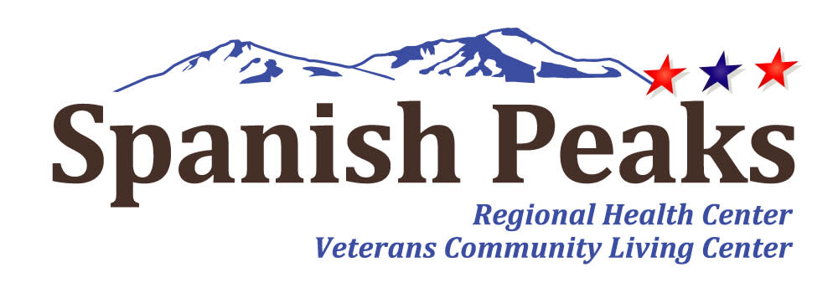

Spanish Peaks Regional Health Center-Huerfano County Hospital District
Regular Board Meeting
*Notice of Agenda*

Spanish Peaks Regional Health Center
July 24, 2025, at 12:00 PM MDT to July 24, 2025 at 3:00 PM MDT
23500 US HWY 160 Walsenburg, CO 81089

Microsoft Teams meeting
Join on your computer, mobile app or room device
Click here to join the meeting
Or call in (audio only)
+1 929-352-2641,,708949185# United States, New York City
Phone Conference ID: 708 949 185#

Agenda
- Call to Order, Pledge of Allegiance, & Roll Call
Jill Davis Homerding
- Recognition of Visitors
Jill Davis Homerding
- Minute Approval
Jill Davis Homerding
*Action Item – June 26, 2025 - Regular Board Meeting Minutes
- New Agenda Items
*Quarterly Istonish Update -- Joe DeVenuto
*Quarterly HR Update - Brianna Nazarenus
- State Observers Report
Janet Hutchinson
- CEO Report
Kay Whitley
- NHA Report
Teresa Clift
- Executive Director of Operations Report
Sara Briggs
- CNO Report
Katy Frazier
- CFO Report
Brenda Parnell
- Legislative Committee Update
Lola Spradley
- Quarterly Compliance Update
Maurice Heikes
- Hospital Quarterly Quality Update
JoAnn Ugolini

- VCLC Quarterly Quality Update
John Davis
- SPHC Foundation Report
John Davis
- Old Business
New discussion on open topics
- Community Open Forum

**Before opening our Community Open Forum, please be aware of several requirements that we expect to be followed. First and foremost, this is an opportunity to present your ideas and/or concerns as long as civility is maintained. This will be a respectful session. You will be held to a time limit of 5 minutes. Only one speaker may approach at a time. Also, if requests are made or questions are asked, the Board is under no obligation to respond. This is not a conversation, but rather a place for you to be heard. Thank you.
- Executive Session
MedStaff Credentialing - Dr. Sandeep Vijan
C.R.S. – 24.6-402(4)(g) – consideration of any documents protected by the mandatory nondisclosure provisions of the Open Records Act. Includes: medical records, personnel files, privileged documents (24-72-204(3)(a).
- Adjournment
- Next Meeting
August 28, 2025

