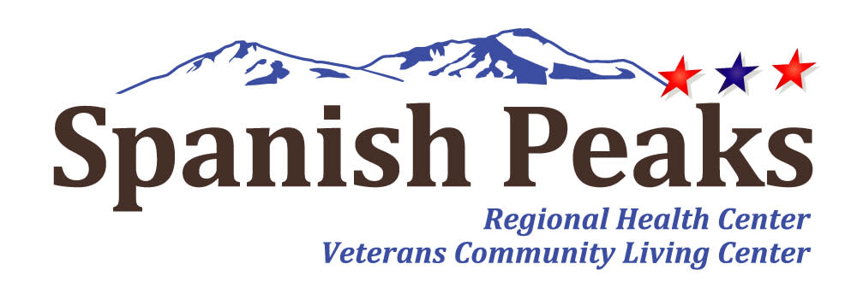

Spanish Peaks Regional Health Center-Huerfano County Hospital District
Special Board Meeting
*Notice of Agenda*

Spanish Peaks Regional Health Center
October 9, 2025, at 11:00 PM MDT to October 9, 2025 at 11:30 PM MDT
23500 US HWY 160 Walsenburg, CO 81089

Microsoft Teams Need help?
Join the meeting now
Meeting ID: 266 667 976 011 5
Passcode: Gi6Ch64f

Dial in by phone
+1 929-352-2641,,804989949# United States, New York City
Find a local number
Phone conference ID: 804 989 949#

Agenda
- Call to Order, Pledge of Allegiance, and Roll Call
Jill Davis Homerding
- Review of 2026 Preliminary Budget
- Adjournment

