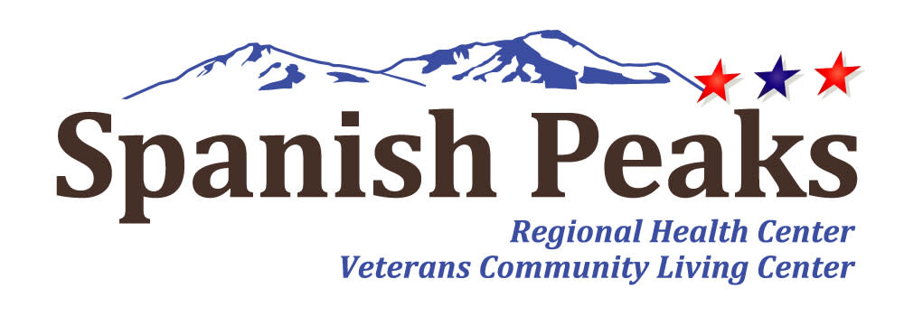

Spanish Peaks Regional Health Center-Huerfano County Hospital District
Regular Board Meeting
*Notice of Agenda*

Spanish Peaks Regional Health Center
September 23, 2025, at 12:00 PM MDT to September 23, 2025 at 3:00 PM MDT
23500 US HWY 160 Walsenburg, CO 81089

Microsoft Teams meeting
Join on your computer, mobile app or room device
Click here to join the meeting
Or call in (audio only)
+1 929-352-2641,,708949185# United States, New York City
Phone Conference ID: 708 949 185#
Find a local number | Reset PIN

Agenda
- Call to Order, Pledge of Allegiance, & Roll Call
Jill Davis Homerding
- Recognition of Visitors
Jill Davis Homerding
- Minute Approval
Jill Davis Homerding
*Action Item – August 28, 2025 - Regular Board Meeting Minutes
- New Agenda Items
FY2024 Audit presentation
Stockman Kast Ryan
Review of 2026 Preliminary Budget
Ratification of Spanish Peaks Foundation Board Members
Stacy Cristelli
Master Staffing Plan Approval
Sara Briggs
*Approval of Master Staffing Plan
- State Observers Report
Janet Hutchinson
- CEO Report
Kay Whitley
- NHA Report
Teresa Clift
- Executive Director of Operations Report
Sara Briggs
- CFO Report
Brenda Parnell
- SPRHC Quarterly Compliance Update
Maurice Heikes
- Legislative Committee Update
Lola Spradley
- SPHC Foundation Report
John Davis
- Old Business
New discussion on open topics
- Community Open Forum

**Before opening our Community Open Forum, please be aware of several requirements that we expect to be followed. First and foremost, this is an opportunity to present your ideas and/or concerns as long as civility is maintained. This will be a respectful session. You will be held to a time limit of 5 minutes. Only one speaker may approach at a time. Also, if requests are made or questions are asked, the Board is under no obligation to respond. This is not a conversation, but rather a place for you to be heard. Thank you.
- Executive Session
C.R.S. - 24-6-402(4)(b) - Conferences with an attorney for the public entity for the purposes of receiving legal advice on specific legal questions. Notes: 1) Mere presence of the attorney is not sufficient; 2) State topic of the legal questions in as much detail as possible without disclosing confidential information.
C.R.S. – 24.6-402(4)(g) – consideration of any documents protected by the mandatory nondisclosure provisions of the Open Records Act. Includes: medical records, personnel files, privileged documents (24-72-204(3)(a).
- Adjournment
- Next Meeting
October 23, 2025

